Oral History Western Australia
Saturday 16 July 2022
For volunteers & interested others:
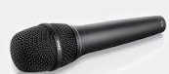
Conducting an ethical and successful oral history
Dear OHWA Members and Friends,
We are pleased to invite you to attend an introductory oral history interviewing skills workshop, conducted by one of the OHWA’s very experienced life members, Jan McCahon Marshall.
Come along so Jan can introduce you to aspects of an interview such as: gaining written consent from an interviewee; confidentiality; questioning techniques; the completed interview, and more.
Covid interrupted our earlier attempts to host this workshop, but we anticipate that we’ll have more success with planned small group workshops in the coming months. Masks are not mandatory, but you may prefer to wear one.
Date Saturday 16 July Time 10:00 am to 4:00 pm
Venue Tuart College Campus, corner Banksia and Hodgson Streets, Tuart Hill in the WA Multicultural Association Centre
RSVP with contact details by 12 July to Lynn at contact@oralhistorywa.org.au (Preferred option)
If unable to email, then phone Lynn O’Hara T. 0408 959 006

Cost $70 Pre-payment to
Account name: Oral History WA Inc BSB 066 155 Account number 10484448
IDENTIFY your e-payment: WshopJul16 Last name First name initial

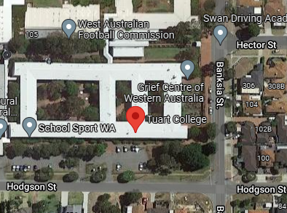
For more information see the OHWA website https://oralhistorywa.org.au
Enter building from Hodgson Street

Important notes: 1. Bring your mobile phones or handheld recorders for recording practice
2. Morning & afternoon tea/coffee provided but bring your own lunch
3. Participants limited to 10 people
4. Save your practice recording for the transcribing workshop (late July)

