Oral History Western Australia
Saturday 30 July 2022
For volunteers and interested others
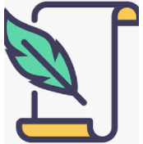
Transcribing a recorded interview
Dear OHWA Members and Friends,
We are pleased to invite you to attend an introductory transcribing workshop, conducted by one of the OHWA’s very experienced life members, Jan McCahon Marshall.
Come along so Jan can introduce you to the protocols of transcribing an oral history recorded interview.
Covid interrupted our earlier attempts to host this workshop, but we anticipate that we’ll have more success with planned small group workshops in the coming months. Masks are not mandatory, but you may prefer to wear one.
Date Saturday 30 July Time 10:00 am to 1:00 pm
Venue Tuart College Campus, corner Banksia and Hodgson Streets, Tuart Hill in the WA Multicultural Association Centre
RSVP with contact details by 27 July to Lynn at contact@oralhistorywa.org.au (Preferred option). If unable to email, then phone Lynn O’Hara T. 0408 959 006
Cost $40 Pre-payment to
Account name: Oral History WA Inc BSB 066 155 Account number 10484448
IDENTIFY your e-payment: WshopJul30Last name First name initial

For more information see the OHWA website https://oralhistorywa.org,au
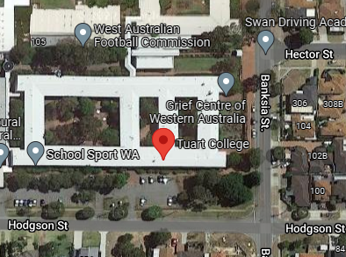 Enter building from Hodgson Street
Important notes:
1. Bring your mobile phones or handheld recorders with a saved interview recording
2. Morning tea/coffee provided but a short break will allow time to eat a quick BYO lunch
3. Participants limited to 10 people
4. Participants need pens and paper to supplement handout material

